MAHATMA EDUCATION SOCIETY’S

PILLAI COLLEGE OF ARTS, COMMERCE & SCIENCE
(Autonomous)
NEW PANVEL

PROJECT REPORT ON
“Baudhayana: The Ancient Mathematician and Sage”

IN PARTIAL FULFILLMENT OF
BACHELOR OF COMPUTER APPLICATION
SEM 1
2025 26

PROJECT GUIDE:
Adv. POONAM GUPTA

SUBMITTED BY: SAUMYA KANTI SARMA
ROLL NO: 2570

Baudhayana: The Ancient Mathematician and Sage
Introduction
Long before the rise of Greek mathematicians like Pythagoras and Euclid, India had already laid the foundations of mathematical and geometrical reasoning through its sacred texts known as the Sulba Sutras. Among the earliest contributors to this tradition was Baudhayana (also known as Budhya). He was a revered Vedic scholar, mathematician, and author of the Baudhayana Sutras. His work, especially the Baudhayana Sulba Sutra, contains some of the earliest known formulations of geometrical principles, including the famous Pythagorean theorem, centuries before Pythagoras.

About Baudhayana
Baudhayana (Sanskrit: बौधायन, Romanised: Baudhayana) was an ancient Indian mathematician and Vedic sage, believed to have lived around the 8th-7th century BCE. He is renowned for his contributions to early Indian mathematics and geometry, primarily through his authorship of the Baudhayana Sutras. His birth anniversary is known as Baudhayana Jayanti or Bodhayan Jayanti or Bodhayan Janmotsav in the Mithila region.
Baudhayana’s intellectual contributions extended far beyond mathematics. His texts encompass subjects like ritual, philosophy, ethics (dharma), and geometry, reflecting the deep interconnection between science and spirituality in ancient Indian scholarship. His works are considered among the oldest surviving texts of the Taittiriya branch of the Krishna Yajurveda, dating back to around the 1st millennium BCE. Baudhayana was a revered philosopher as well as a great Indian mathematician during 700 BC. He was the author of several ancient texts composed in the ancient Indian subcontinent. He composed more than two hundred texts. He gave many important theories of mathematics. He is known for the famous mathematical theory Baudhayana Sulba Sutra.

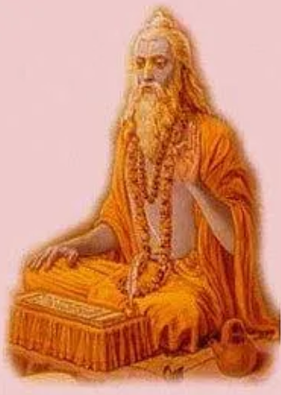

In the text Astadhyayi, he is described as the guru of the famous Sanskrit grammarian Panini. He was a great scholar of philosophy, theology, mathematics and language. His important works were Vedvrti, Vedanta, Ratna Manjusa, Dharmasutra and Grhyasutra. Baudhayana Dharmasutra and Baudhayana Grihya Pari Sista Sutra are the two major texts composed by him, which emphasize the ritualistic manner and philosophy of the Hindu tradition. His school of thought in Hindu tradition is known as the Baudhayana Sakha or Baudhayana school. The Baudhayana Sakha consider the practices of image worship in Hinduism. It is affiliated to the Taittiriya recension of Krishna Yajurveda. In the Baudhayana school, Lord Vishnu is considered as the highest being and called as Mahapurusha. Apart from Lord Vishnu, it also considers all other deities in Hinduism as “Worthy of honour”.
His other notable work is Baudhayana Srauta Sutra. It is the oral lectures delivered by him to his disciples and belongs to the Taittiriya recension of the Krishna Yajurveda.
According to legend in the Mithila region, Baudhayana is also called as Bhagwan Bodhayana. He was born on the Dvada Si (twelfth day) in Krishna Paksa of Pausha month in the Hindu calendar. He was born at the Bangaon village of the Bajpatti block in the Sitamarhi district of the Mithila region in the present state of Bihar in India. His childhood name was Upvarsha. His father’s name was Shankardutt and mother’s name was Charumati. His father was a scholar of Pataliputra.

Baudhayana Jayanti is majorly celebrated in the Mithila region. A grand ceremony of Baudhayana Jayanti is organised at the campus of the Swami Bodhayan Mandir in the Sitamarhi district of Bihar since 1957. On the occasion of the celebration, sadhu-saints and sages are invited. A 7-day long Srimad Bhagwat Katha is organised in the campus of the temple. The preparation of the festive celebration starts a week before the Baudhayana Jayanti. It starts with celebration of a Kalash Sobha Yatra procession. Every year a huge feast is organized here. A large number of devotees gather here on the Bodhayan Jayanti. They take sacred bath in the pond situated in the campus of the temple. They do parikrama and worship the statue of Bodhayan in the temple.
The Bodhayan Janmotsav has been proposed as a state festival in Bihar by the state minister Jivesh Mishra. In 2022, he assured the people of Mithila that the Bodhayan Jayanti would be given the status of a state festival through the Art and Culture department.

The Baudhayana Sutras
The Baudhayana Sutras are a group of Vedic Sanskrit texts that form part of the vast corpus of Kalpa Sutra literature. These texts codified practical instructions for performing rituals, moral conduct, and geometry required for constructing Vedic altars. The collection consists of six main texts:
- Srauta Sutra: covering elaborate Vedic rituals and sacrifices
- Karmanta Sutra: describing ritual procedures in 20 chapters
- Dwaidha Sutra: containing 4 sections of ritual discussions
- Grhya Sutra: related to domestic rites and ceremonies
- Dharma Sutra: focused on ethics, duties, and social conduct
- Sulba Sutra: dealing with geometry and mathematics
The Sulba Sutra, in particular, has earned Baudhayana recognition as one of the earliest mathematicians in human history.
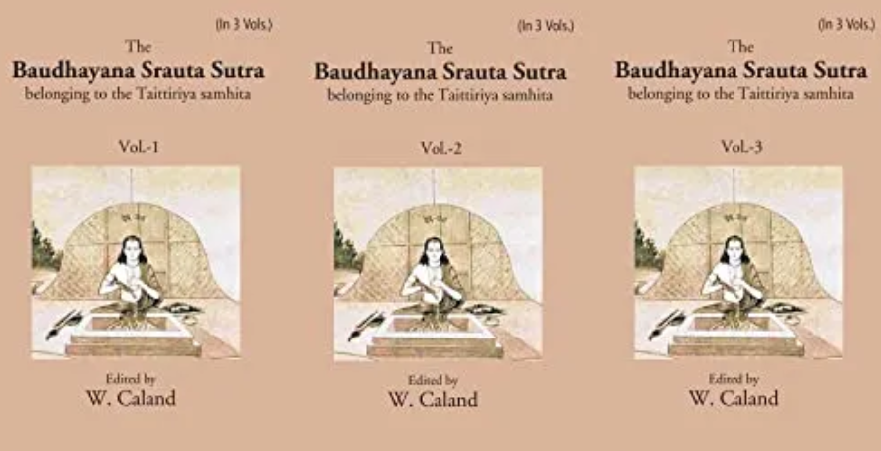

Baudhayana Sulba Sutra and Early Mathematics

The Sulba Sutra (literally, “rules of the cord”) was essentially a manual for the geometric construction of altars (yajña bhumikas). Since ritual precision was of utmost importance in Vedic traditions, exact measurements were essential. This necessity led to the development of early geometry in India.

The Pythagorean Theorem: Long Before Pythagoras
One of Baudhayana’s most significant contributions is his statement of what is now known as the Pythagorean theorem. The Baudhayana Sulba Sutra explicitly describes the relationship between the diagonal and the sides of a rectangle:
दीर्घचतुरस्रस्याक्ष्णया रज्जुः पार्श्वमानी तिर्यग् मानी च यत् पृथग् भूते कुरूतस्तदुभयं करोति ॥
“The diagonal of a rectangle produces by itself both the areas which the two sides produce separately.”
This statement, dating to centuries before Pythagoras, is mathematically identical to the theorem we express today as $a^{2}+b^{2}=c^{2}$.
Baudhayana also extended this rule to special cases like the isosceles right triangle, demonstrating a deep understanding of geometrical relationships:
“The cord which is stretched across a square produces an area double the size of the original square.”
This indicates that Baudhayana not only understood the principle but could apply it to derive related geometric results — a level of abstraction that reflects a sophisticated mathematical culture.

Approximating the Square Root of 2
Another extraordinary feature of the Baudhayana Sulba Sutra is its remarkably accurate approximation of √2, a value essential for diagonal measurements of squares and rectangles. Baudhayana wrote:
“The measure is to be increased by a third and by a fourth decreased by the 34th. That is its diagonal approximately.”
Mathematically, this can be expressed as:
$$\sqrt{2}≈1+\frac{1}{3}+\frac{1}{3×4}-\frac{1}{3×4×34}=\frac{577}{408}≈1.414216$$
This value is accurate to five decimal places, a level of precision that was unmatched in most ancient civilizations. It showcases the advanced understanding of numerical methods in Vedic India, long before the advent of modern decimal systems.

Other Geometric Insights
The Sulba Sutra is filled with numerous other geometric observations and constructions, such as:
- The diagonals of a rectangle bisect each other.
- The diagonals of a rhombus intersect at right angles.
- The area of a square formed by joining the midpoints of another square is half of the original square.
- Joining the midpoints of a rectangle forms a rhombus whose area is half the rectangle.
Each of these results reveals how the pursuit of religious accuracy in altar-building inspired remarkable geometric discovery.

Circling the Square
Baudhayana also attempted one of geometry’s most famous challenges: “squaring the circle”, or in his case, finding a circle with the same area as a square. His method, described in the Sulba Sutra (I.58), states:
“Draw half its diagonal about the centre towards the East–West line; then describe a circle together with a third part of that which lies outside the square.”
This procedure gives a value for π (pi) close to 3.088, which, though not exact, represents a serious and practical attempt to relate the two fundamental geometric shapes. This demonstrates that Baudhayana was likely the first mathematician in recorded history to calculate the value of π.

Baudhayana Dharmasutra

Beyond mathematics, Baudhayana composed the Dharmasutra, a text that explores ethics, law, and social duties. It consists of four books, each addressing different aspects of human life:
- Book One- Duties of students, social classes, the role of the king, and marriage.
- Book Two- Penances, inheritance, and the life of a householder.
- Book Three- Conduct of hermits and ascetics.
- Book Four- Yogic practices and moral offenses.
The Dharmasutra provides valuable insight into the ethical and social systems of Vedic society, balancing moral conduct with ritual discipline. It also reveals that Baudhayana’s school continued to evolve through commentary and reinterpretation by later scholars, including Govindasvamin.

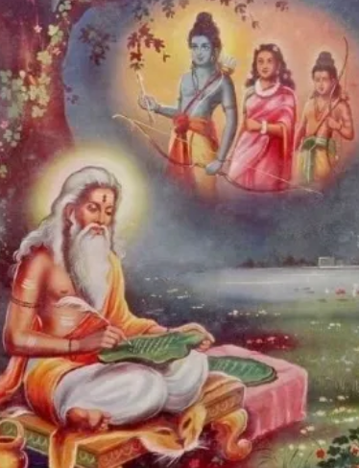

Baudhayana Srauta Sutra and Ritual Practices

The Baudhayana Srauta Sutra deals with the performance of solemn Vedic sacrifices ( Srauta yajñas). Followers of this tradition can still be found among some Smarta Brahmins and Iyengars of Tamil Nadu and Kerala. These texts meticulously describe the layout of altars, offerings, and recitations blending geometry, astronomy, and ritual precision.
Baudhayana’s school pioneered the Sutra style of writing concise, formulaic statements that condensed complex ritual procedures into brief aphorisms. This linguistic innovation later influenced Panini, the great Sanskrit grammarian, whose Astadhyayi perfected the sutra format.

Historical Context and Influence

Baudhayana’s works were composed during the late Vedic or early Brahmana period, roughly between 800-500 BCE. Scholars like W. Caland have suggested that Baudhayana originally belonged to the Kanva school of the White Yajurveda, but later adopted the Taittiriya school. His teachings were transmitted orally for centuries before being written down and preserved by the Baudhayana lineage.
His texts also reflect the intellectual transitions of ancient India from descriptive ritual manuals to concise analytical reasoning. In this sense, Baudhayana marks the beginning of formal scientific thought within Indian civilization.

Legacy and Controversies

Baudhayana’s name occasionally appears in modern debates about the origins of Indo-Aryan culture. A passage from his Srauta Sutra (18.44) was interpreted by some Western Indologists, including Michael Witzel, as evidence for Indo-Aryan migrations into India. However, several Indian scholars and archaeologists, such as B.B. Lal and Koenraad Elst, have challenged this interpretation, arguing that the text more plausibly refers to internal migrations within the Indian subcontinent.
While these debates continue, it is important to recognize that Baudhayana’s significance lies not in political theories but in his intellectual achievements his synthesis of ritual, mathematics, and philosophy into a coherent system of knowledge.

Conclusion

Baudhayana was far more than a ritualist; he was an early scientist, mathematician, and philosopher who bridged the sacred and the rational. His Sulba Sutra stands as a monument to India’s ancient mathematical wisdom, offering clear evidence that the concept of the Pythagorean theorem and advanced geometry were known in India long before they appeared elsewhere.
By exploring the relationship between mathematics and ritual, Baudhayana revealed that science and spirituality need not be separate they can coexist as complementary paths to understanding the universe. His meticulous methods, precise measurements, and profound insights continue to inspire students of Indian Knowledge Systems even today.
In honoring Baudhayana, we not only celebrate an ancient mathematician but also recognise a visionary who laid the groundwork for a scientific tradition deeply rooted in India’s cultural and philosophical heritage.

